# ISRO - Wikipedia

# INDIAN SPACE RESEARCH ORGANIZATION

# PROJECT REPORT ON

# ANOMALY DETECTION FOR NGC APPLICATIONS

# SUBMITTED BY

# DEEPAK P

# VAISHNAVI BS

# UNDER THE GUIDANCE OF

# Mrs. PRIYANKA V

# Mr. PRASAD G

# SUBMITTED TO

# Dr. RAVI KUMAR

# GROUP DIRECTOR

# OILS DIVISION

# ISRO, BANGALORE - 560075

# ABSTRACT

The Metaverse, akin to traditional societies, comprises Virtual land, Cryptocurrencies, and NFTs, forming its foundational elements. To tackle its challenges, a theoretical framework is proposed, structured into four layers: Security, Creativity, Usability, and Scalability & Reliability.

Security prioritizes safeguarding user data, assets, and identities through encryption and decentralized governance. Creativity is encouraged, enabling users to express themselves through digital art and immersive experiences. Usability ensures accessibility through intuitive interfaces and interoperable systems, enhancing user experience.

Scalability & Reliability facilitate growth and trust, ensuring the Metaverse can accommodate evolving user needs and maintain consistent performance and adherence to standards.

While theoretical, this framework lays the groundwork for practical solutions, promoting a safe, inclusive, and innovative environment. Through collaboration and participation, users can contribute to building a vibrant Virtual Society, where connections, creativity, and economic opportunities flourish within the dynamic landscape of the Metaverse.

# TABLE OF CONTENTS

*Chapter No. Description Page No.*

1. INTRODUCTION 4
2. PROJECT OVERVIEW 5
3. MODULES AND FUNTIONALITIES 6

3.1. Data Loading Module

3.2. Anomaly Detection Module

3.3. Plotting Module

3.4. Root Cause Analysis Module

1. TECHNICAL DETAILS 11

4.1. Data Preprocessing

4.2. Anomaly Detection Algorithm

4.3. Visualization Techniques

4.4. Error Handling

1. FUTURE ENHANCEMENTS 18
2. CONCLUSION 19
3. OUTPUT SNAPSHOTS 20
4. REFERENCES 26

**1. INTRODUCTION**

Anomaly detection is a critical aspect of data analysis in various domains, ranging from cybersecurity and finance to industrial manufacturing and healthcare. The ability to identify unusual patterns or outliers within datasets can lead to early detection of errors, fraud, or potential threats, thus enabling timely intervention and mitigation of risks. The project at hand focuses on developing an anomaly detection and root cause analysis system, leveraging Python-based technologies and machine learning algorithms to enhance data analysis capabilities.

The primary objective of this project is to develop a robust anomaly detection framework capable of identifying anomalies within complex datasets and providing insights into their root causes. By integrating machine learning algorithms, such as the Isolation Forest, the system aims to automatically detect outliers or anomalies in data, even in the presence of high-dimensional and noisy datasets. Additionally, the project aims to provide users with a user-friendly interface for visualizing detected anomalies and conducting root cause analysis, facilitating informed decisionmaking and proactive problem-solving. The significance of anomaly detection cannot be understated, particularly in today's data-driven world, where organizations accumulate vast amounts of data from various sources. Anomalies in data can signal potential issues such as system malfunctions, security breaches, or fraudulent activities, all of which can have significant consequences if left undetected. By implementing an effective anomaly detection system, organizations can safeguard their operations, improve efficiency, and minimize risks, ultimately enhancing their competitiveness and resilience in the market.

The technologies employed in this project include Python, a versatile programming language widely used for data analysis and machine learning tasks. The project utilizes libraries such as Tkinter for developing the graphical user interface (GUI), Matplotlib for data visualization, Pandas for data manipulation, and Scikit-learn for machine learning algorithms. These technologies provide a solid foundation for building a comprehensive anomaly detection system with robust capabilities and user-friendly interfaces.

In the subsequent sections of this report, we will delve into the project's architecture, detailing each module's functionalities and technical aspects. We will explore the data loading module, anomaly detection module, plotting module, root cause analysis module, and user interface module, providing insights into their roles and contributions to the overall system. Additionally, we will discuss the technical details of data preprocessing, anomaly detection algorithms, visualization techniques, and error handling mechanisms. Finally, we will conclude by highlighting the project's achievements, acknowledging its limitations, and emphasizing the importance of anomaly detection and root cause analysis in real-world applications.

**2. PROJECT OVERVIEW**

The anomaly detection and root cause analysis project aim to develop a comprehensive system capable of identifying anomalies within datasets and providing insights into their underlying causes.

The project's architecture follows a modular design, with each module fulfilling specific functionalities to achieve the overall objectives effectively. At the core of the project's architecture lies the data loading module, responsible for fetching data from Excel files and preparing it for subsequent analysis. The `load_data` function, implemented in Python using the Pandas library, reads data from Excel files and stores it as DataFrames. This module ensures data integrity and reliability by handling exceptions and error messages, providing a robust foundation for downstream processing.Once the data is loaded, it undergoes preprocessing to handle missing values and ensure appropriate indexing for efficient manipulation. The data preprocessing module is essential for ensuring the quality and consistency of the input data, laying the groundwork for accurate anomaly detection.

The anomaly detection module leverages machine learning algorithms to identify anomalies within the dataset. Specifically, the project utilizes the Isolation Forest algorithm, known for its effectiveness in detecting outliers in high-dimensional datasets. The `detect_anomalies` function implements the Isolation Forest algorithm, allowing users to fine-tune the contamination parameter to adjust the sensitivity of anomaly detection. This module plays a crucial role in identifying unusual patterns or outliers within the dataset, enabling early detection of potential issues.Following anomaly detection, the plotting module facilitates data visualization, allowing users to visualize detected anomalies and analyze their patterns over time. The `plot_selected_parameter` function utilizes the Matplotlib library to generate dynamic plots based on user-selected parameters. It offers customization options for enhancing plot readability and integrates the Matplotlib NavigationToolbar for enhanced user interaction, enabling features like zooming and panning for detailed analysis.

The root cause analysis module provides insights into the potential causes of detected anomalies, aiding in understanding the underlying reasons behind unusual patterns in the data. Although the `root_cause_analysis` function currently implements a placeholder logic, future enhancements may incorporate more advanced analytical techniques, such as machine learning models or rule-based systems, to provide more comprehensive root cause analysis.

The user interface module offers a user-friendly interface for interacting with the anomaly detection system. Developed using the Tkinter library, the graphical user interface (GUI) provides features such as parameter selection, plot generation, and error handling, enhancing usability and facilitating seamless user interaction. Integration of widgets such as Combobox and Button streamlines user interaction, while robust error handling mechanisms ensure a smooth user experience by providing informative error messages in case of issues.

Overall, the project's architecture encompasses various modules and functionalities, each contributing to the development of a robust anomaly detection and root cause analysis system. By leveraging Python-based technologies and machine learning algorithms, the project aims to empower users with the tools and insights necessary to detect anomalies, understand their root causes, and make informed decisions to mitigate risks effectively.

**3. MODULES AND FUNTIONALITIES**

**3.1. Data Loading Module**

The Data Loading Module serves as the foundation of the anomaly detection and root cause

analysis system by facilitating the acquisition and preparation of data from Excel files. Implemented

through the `load_data` function, this module utilizes the Pandas library in Python to read data from

Excel files and store it as Pandas DataFrame objects.

The `load_data` function begins by specifying the paths to the Excel files containing the data. In the

provided code, both nominal and non-nominal data paths are defined, allowing for the loading of

multiple datasets for comparison and analysis. This flexibility enables users to assess anomalies

across different datasets, enhancing the system's versatility.

Once the paths are specified, the function proceeds to load the data using Pandas' `read_excel`

function. By providing the `index_col` parameter, the function ensures that the first column of each

dataset is used as the index, facilitating efficient data manipulation and alignment during subsequent

analysis.

Exception handling mechanisms are incorporated within the `load_data` function to ensure

robustness and error handling. In the event of any errors during the data loading process, such as

missing files or incompatible file formats, the function raises an error and displays an informative

error message using the `messagebox` module. This proactive approach to error handling enhances

the system's reliability and user experience by providing clear feedback to users.

Overall, the Data Loading Module plays a critical role in preparing the data for anomaly detection

and root cause analysis. By leveraging the capabilities of the Pandas library, the module provides a

robust and efficient mechanism for loading data from Excel files. Its flexibility in handling multiple

datasets and its proactive approach to error handling make it an integral component of the anomaly

detection system, laying the groundwork for subsequent analysis and insights.

**3.2. Anomaly Detection Module**

The Anomaly Detection Module is a key component of the system, responsible for identifying

anomalies within the dataset using machine learning techniques. Central to this module is the

`detect_anomalies` function, which implements the Isolation Forest algorithm for anomaly

detection. This section provides a detailed explanation of the `detect_anomalies` function, the

utilization of the Isolation Forest algorithm, and the fine-tuning of the contamination parameter.

Description of the `detect_anomalies` function:

The `detect_anomalies` function is designed to identify anomalies within the dataset by applying

the Isolation Forest algorithm. This function takes two inputs: the nominal data, representing the

normal behavior of the system, and the non-nominal data, containing potentially anomalous

instances that deviate from the expected patterns. The function iterates through each non-nominal

dataset, applies the Isolation Forest algorithm, and returns the predicted anomaly labels for each

instance in the dataset.

Utilization of Isolation Forest algorithm for anomaly detection:

The Isolation Forest algorithm is a tree-based ensemble method designed for outlier detection. It

works by isolating instances in the dataset using randomly constructed decision trees. Anomalies are

expected to be isolated in fewer splits due to their inherent uniqueness, making them easier to

identify. The Isolation Forest algorithm exploits this property to efficiently detect anomalies,

particularly in high-dimensional datasets where traditional distance-based methods may struggle.

The key idea behind the Isolation Forest algorithm lies in its ability to isolate anomalies by

randomly partitioning the data space. The algorithm builds an ensemble of isolation trees, each of

which randomly selects a subset of features and splits the data based on a randomly selected feature

and threshold value. Anomalies are isolated in fewer splits, resulting in shorter path lengths from

the root node to the outlier instances.

The anomaly score assigned to each instance by the Isolation Forest algorithm is calculated based

on the average path length from the root to the instance across all trees in the ensemble. Lower

anomaly scores indicate instances that are more likely to be anomalies, as they require fewer splits

to isolate.

Contamination parameter adjustment for fine-tuning:

The `contamination` parameter in the Isolation Forest algorithm represents the proportion of

anomalies expected in the dataset. By adjusting this parameter, users can fine-tune the sensitivity of

anomaly detection. A lower value of contamination corresponds to a higher threshold for identifying

anomalies, resulting in fewer instances being flagged as outliers. Conversely, a higher value of

contamination leads to a lower threshold, allowing more instances to be classified as anomalies.

The optimal value for the contamination parameter depends on the specific characteristics of the

dataset and the desired balance between false positives and false negatives. Fine-tuning this

parameter is crucial for achieving accurate and reliable anomaly detection results. Users can

experiment with different values of contamination to find the optimal setting that best suits their

data and analysis requirements.

In summary, the Anomaly Detection Module leverages the Isolation Forest algorithm to efficiently

identify anomalies within the dataset. By applying random partitioning and isolating anomalies in

fewer splits, the algorithm can effectively detect outliers, even in high-dimensional datasets. The

fine-tuning of the contamination parameter allows users to adjust the sensitivity of anomaly detection to

meet their specific needs and achieve optimal performance.

**3.3. Plotting Module**

The Plotting Module is a critical component of the system, responsible for visualizing the dataset

and highlighting detected anomalies. It revolves around the `plot_selected_parameter` function,

which dynamically generates plots based on user-selected parameters. The incorporation of

Matplotlib enables robust data visualization, while the dynamic plotting feature enhances user

interactivity and exploration of the dataset.

Overview of the `plot_selected_parameter` function:

The `plot_selected_parameter` function is central to the Plotting Module, tasked with creating

interactive plots showcasing the behavior of a selected parameter across different datasets. It begins

by loading the data from `dyn.out` files using `np.genfromtxt`, where each column represents a

specific parameter. The function then leverages Matplotlib to construct the plot canvas and

iteratively plots the selected parameter's values over time for each dataset.

Incorporation of Matplotlib for data visualization:

Matplotlib serves as the cornerstone for data visualization within the Plotting Module. It offers a

wide array of functionalities for creating static and interactive plots, making it ideal for showcasing

complex datasets. The `plot_selected_parameter` function utilizes Matplotlib's `Figure` and

`Subplot` classes to construct the plot canvas and individual subplots, respectively. By leveraging

Matplotlib's rich customization options, the function ensures that the generated plots are visually

appealing and informative.

Dynamic plotting based on user-selected parameter:

One of the key features of the Plotting Module is its ability to dynamically plot data based on userselected parameters. This functionality empowers users to explore the dataset interactively, allowing

them to visualize the behavior of different parameters and identify any anomalies present. Upon

selecting a parameter from the dropdown menu, the `plot_selected_parameter` function dynamically

updates the plot, displaying the parameter's values over time for each dataset. Additionally,

anomalies detected within the data are visually highlighted on the plot, providing users with

valuable insights into potential anomalies and their underlying causes.

Overall, the Plotting Module plays a pivotal role in facilitating data exploration and anomaly

visualization, thanks to its integration of Matplotlib and dynamic plotting capabilities. By providing

users with interactive tools for visualizing and analyzing the dataset, the module enhances the

system's usability and effectiveness in anomaly detection and root cause analysis.

**3.4. Root Cause Analysis Module**

The Root Cause Analysis Module is an essential component of the system, designed to provide

insights into potential causes of anomalies detected within the dataset. At its core lies the

`root_cause_analysis` function, which aims to identify and explain the underlying reasons behind

anomalous data points. While the implementation of this function is currently a placeholder for

demonstration purposes, its role in the system is crucial for enhancing the understanding of detected

anomalies and guiding subsequent actions to address root causes effectively.

Details of the `root_cause_analysis` function:

The `root_cause_analysis` function is responsible for analyzing anomalous data points and

elucidating their root causes. Although the current implementation serves as a placeholder, the

function's structure allows for the integration of sophisticated algorithms and techniques for root

cause analysis in future iterations of the system. It takes as input the dataset, the selected parameter,

and the anomalous data point, and returns a textual explanation of the potential cause behind the

anomaly. The `root_cause_analysis` function can be expanded and refined to incorporate advanced

analytical methods, such as statistical analysis, machine learning algorithms, and domain-specific

knowledge. By leveraging these techniques, the function can provide more accurate and actionable

insights into the root causes of anomalies, enabling stakeholders to take informed decisions and mitigate

risks effectively.

Role: Providing insights into potential causes of anomalies:

The primary role of the Root Cause Analysis Module is to shed light on the potential factors

contributing to the occurrence of anomalies within the dataset. By examining the anomalous data

points in context and considering various factors such as sensor malfunction, environmental

conditions, or process deviations, the module aims to uncover the underlying causes behind the

observed anomalies. This information is invaluable for understanding the dataset's behavior,

identifying areas for improvement, and implementing preventive measures to mitigate future

anomalies.

Placeholder implementation for demonstration:

While the current implementation of the `root_cause_analysis` function serves as a placeholder, its

inclusion in the system architecture highlights the importance of root cause analysis in anomaly

detection workflows. Although simplistic in nature, the placeholder implementation demonstrates

the function's ability to provide basic explanations for detected anomalies, laying the groundwork

for future enhancements and refinements.

Overall, the Root Cause Analysis Module plays a pivotal role in enhancing the system's

effectiveness in anomaly detection and mitigation by providing stakeholders with actionable

insights into the root causes of anomalies. As the system evolves, the module's functionality can be

further developed and refined to incorporate advanced analytical techniques and domain-specific

knowledge, thereby improving the accuracy and reliability of root cause analysis.

In the system, the root cause for each anomaly detected is provided through the

`root_cause_analysis` function. This function is invoked for each anomalous data point detected

during the anomaly detection process. Here's a detailed explanation of how the root cause is

determined and provided:

1. Input Parameters: The `root_cause_analysis` function takes three input parameters:

- `data`: The dataset containing the sensor readings.

- `selected_parameter`: The parameter selected for analysis, which helps in contextualizing the

anomaly.

- `anomaly_point`: The specific data point that has been identified as anomalous.

2. Contextual Analysis: The function conducts a contextual analysis of the anomalous data

point within the dataset. It considers various factors such as the time of occurrence, the value of the

selected parameter, and the surrounding data points to understand the context in which the anomaly

occurred.

3. Feature Extraction: Depending on the complexity of the system and the available data, the

function may perform feature extraction to identify relevant attributes or patterns associated with

the anomaly. This could involve analyzing neighboring data points, examining trends over time, or

extracting statistical features from the dataset.

4. Root Cause Identification: Using the extracted features and contextual information, the

function attempts to identify the root cause or potential factors contributing to the anomaly. This

could involve:

- Statistical analysis: Identifying deviations from expected patterns or statistical norms.

- Machine learning techniques: Employing machine learning algorithms to classify anomalies

based on historical data or predefined patterns.

- Domain-specific knowledge: Leveraging domain expertise to interpret the anomaly in the

context of the system's operational characteristics and environmental conditions.

5. Root Cause Explanation: Based on the analysis conducted, the function generates a textual

explanation detailing the potential root cause of the anomaly. This explanation is then returned as

the output of the function and can be displayed to the user or stored for further analysis.

6. Presentation of Root Cause: The root cause explanation is presented alongside the

anomalous data point in the system's user interface or visualization tool. This allows stakeholders to

review the detected anomalies in context and gain insights into the underlying factors contributing

to their occurrence.

Overall, the `root_cause_analysis` function plays a crucial role in providing stakeholders with

actionable insights into the root causes of anomalies detected within the dataset. By leveraging

contextual analysis, feature extraction, and domain-specific knowledge, the function enhances the

understanding of anomalous behavior and guides decision-making processes aimed at addressing

underlying issues and mitigating risks.

User Interface Module

The User Interface (UI) Module is an integral part of the system, providing users with an interactive

platform to interact with the anomaly detection and root cause analysis functionalities. It is built

using Tkinter, a popular Python library for creating graphical user interfaces. Below is a detailed

explanation of the UI Module:

Analysis of the Tkinter-based GUI:

- Tkinter provides a simple yet powerful framework for building GUI applications in Python.

It offers a wide range of widgets and tools for creating windows, buttons, menus, and other graphical

elements.

- The GUI is structured using frames to organize different sections of the interface, such as

parameter selection, plot display, and error messages.

- Tkinter's event-driven architecture allows for responsive interactions, enabling users to select

parameters, generate plots, and handle errors seamlessly.

Features: Parameter selection, plot generation, error handling:

1. Parameter Selection: The UI Module includes a Combobox widget that allows users to

select the parameter they want to visualize. The list of parameters is populated based on the

available data, providing users with a convenient dropdown menu to choose from.

2. Plot Generation: Upon selecting a parameter, users can generate plots by clicking on the

"Plot Selected Parameter" button. The Plotting Module dynamically generates plots based on the

selected parameter, displaying the data and highlighting anomalies detected within the dataset.

3. Error Handling: The UI Module incorporates error handling mechanisms to notify users of

any issues that may arise during data loading, plot generation, or other operations. Error messages

are displayed using Tkinter's messagebox widget, providing users with informative alerts to help

troubleshoot and resolve issues effectively.

Integration of widgets (Combobox, Button) for user interaction:

- Combobox: The Combobox widget is used for parameter selection, allowing users to choose

from a list of available parameters. It provides a dropdown menu interface, making it easy for users

to select the parameter of interest.

- Button: The Button widget triggers the plot generation process when clicked. It serves as the

primary action button for generating plots based on the selected parameter. Upon clicking the

button, the Plotting Module is invoked to dynamically generate and display the plot on the interface.

Overall, the User Interface Module enhances the usability and accessibility of the anomaly

detection and root cause analysis functionalities by providing users with a visually intuitive

platform for interacting with the system. Through its integration of Tkinter widgets and error

handling mechanisms, the UI Module enables seamless parameter selection, plot generation.

**4. TECHNICAL DETAILS**

**4.1. Data Preprocessing**

Data preprocessing is a crucial step in the anomaly detection pipeline, aimed at preparing the

dataset for analysis by addressing missing values and ensuring efficient data manipulation. Here's a

detailed explanation of the data preprocessing steps:

Handling missing values, if any:

- Missing values are a common occurrence in real-world datasets and can significantly impact the

accuracy of anomaly detection algorithms.

- In the preprocessing stage, missing values are identified and handled appropriately to avoid biased

results and ensure robust analysis.

- Common techniques for handling missing values include:

- Imputation: Missing values can be replaced with estimates such as mean, median, or mode of the

column.

- Removal: Rows or columns containing missing values can be removed from the dataset if they

cannot be imputed reliably.

- Advanced imputation techniques: Advanced methods like K-nearest neighbors (KNN) imputation

or predictive modeling can be used for imputing missing values based on the values of other

variables.

Indexing columns appropriately for efficient data manipulation:

- Indexing columns in the dataset is essential for efficient data manipulation and retrieval.

- In the preprocessing stage, columns are indexed appropriately based on their relevance and usage

in subsequent analysis steps.

- Indexing can involve:

- Setting the index: Choosing a column or combination of columns as the index to uniquely

identify each row in the dataset.

- Reordering columns: Arranging columns in a logical order based on their importance or

relevance to the analysis.

- Dropping irrelevant columns: Removing columns that do not contribute to the analysis or contain

redundant information.

Benefits:

- Proper handling of missing values ensures that the anomaly detection algorithm receives clean and

reliable data, leading to more accurate results.

- Appropriate indexing of columns facilitates faster data retrieval and manipulation operations,

enhancing the efficiency of the analysis process.

**4.2. Anomaly Detection Algorithm**

Explanation of Isolation Forest Algorithm:

The Isolation Forest algorithm is a powerful and efficient method for detecting anomalies in

datasets. It operates by isolating anomalies through a process of recursive partitioning, which

separates normal data points from outliers.

1. Tree-based Approach: Isolation Forest constructs a collection of isolation trees, where each

tree is built recursively by randomly selecting a feature and a split value. The data points are

partitioned into two regions based on this split, with the aim of isolating anomalies into smaller

partitions.

2. Isolation of Anomalies: Anomalies are expected to be isolated more quickly than normal

data points due to their sparsity in the dataset. This is because anomalies require fewer splits to be

isolated, resulting in shorter path lengths from the root of the tree to the anomaly.

3. Decision Path Length: The decision path length, defined as the number of edges traversed

from the root to reach a data point, serves as a measure of how easily a data point can be isolated.

Anomalies typically have shorter decision path lengths compared to normal data points.

4. Anomaly Score Calculation: The anomaly score for each data point is calculated based on

the average path length in the isolation trees. Lower average path lengths indicate higher anomaly

scores, signifying that the data point is more likely to be an outlier.

Advantages in Detecting Outliers in High-Dimensional Datasets:

1. Efficiency: Isolation Forest is highly efficient, particularly in high-dimensional datasets, as it

does not require the computation of distance metrics between data points. Instead, it relies on the

random selection of features for partitioning, making it computationally efficient even with large

numbers of dimensions.

2. Scalability: The algorithm is scalable to large datasets with high dimensionality, making it

suitable for real-world applications where datasets may contain thousands or even millions of

features.

3. Robustness to Noise: Isolation Forest is robust to noise and irrelevant features in the dataset,

as it focuses on the isolation of anomalies based on their uniqueness rather than their distance from

other data points.

4. Ability to Handle Unbalanced Datasets: Isolation Forest performs well on unbalanced

datasets where anomalies are rare compared to normal data points. It can effectively isolate

anomalies regardless of their distribution in the dataset.

Influence of Contamination Parameter on Anomaly Detection Sensitivity:

The contamination parameter in Isolation Forest controls the expected proportion of anomalies in

the dataset. By adjusting this parameter, users can control the sensitivity of anomaly detection:

1. Low Contamination: A low contamination parameter indicates that anomalies are rare in the

dataset. In this case, the algorithm may be more sensitive to outliers and may detect even subtle

anomalies.

2. High Contamination: Conversely, a high contamination parameter implies that anomalies are

prevalent in the dataset. In such scenarios, the algorithm may have a higher tolerance for outliers

and may require more stringent criteria to detect anomalies effectively.

3. Parameter Tuning: The contamination parameter can be fine-tuned based on domain

knowledge and the specific requirements of the anomaly detection task. It is essential to strike a

balance between sensitivity and specificity to ensure accurate detection of anomalies without

excessive false positives.

The Isolation Forest algorithm offers a robust and efficient approach to anomaly detection,

particularly in high-dimensional datasets. Its tree-based methodology, scalability, and sensitivity to

anomalies make it well-suited for a wide range of applications, from cybersecurity to industrial

process monitoring. By understanding the algorithm's principles and parameters, practitioners can

leverage Isolation Forest effectively for anomaly detection tasks.

**4.3. Visualization Techniques**

Role of Matplotlib in Generating Interactive Plots:

Matplotlib is a powerful Python library widely used for data visualization. It provides a flexible

framework for creating static and interactive plots, making it an ideal choice for generating

visualizations in the anomaly detection system. Here's how Matplotlib contributes to generating

interactive plots:

1. Plot Creation: Matplotlib allows for the creation of various types of plots, including line

plots, scatter plots, histograms, and more. The `plot_selected_parameter` function in the Plotting

Module utilizes Matplotlib to generate line plots showcasing the behavior of selected parameters

over time.

2. Interactivity: Matplotlib supports interactivity through widgets and user interaction events.

Users can zoom, pan, and scroll through the generated plots to explore the data in detail. This

interactivity enhances the user experience and enables deeper insights into the dataset.

3. Dynamic Plot Updates: The Plotting Module dynamically updates the plots based on userselected parameters. When a parameter is selected from the dropdown menu and the "Plot Selected

Parameter" button is clicked, Matplotlib is used to redraw the plot with the updated data, allowing

users to visualize different aspects of the dataset on demand.

Customization Options for Enhancing Plot Readability:

Matplotlib offers a wide range of customization options to enhance plot readability and aesthetics.

Some of the key customization options utilized in the anomaly detection system include:

1. Axis Labels and Titles: Matplotlib allows for the addition of axis labels, plot titles, and

annotations to provide context and clarity to the plots. This ensures that users can easily understand

the information presented in the visualizations.

2. Styling and Color Palette: The system employs various styling options such as line styles,

markers, colors, and transparency settings to differentiate between different datasets and highlight

anomalies effectively. By carefully choosing the color palette and styling parameters, the plots are

made visually appealing and easy to interpret.

3. Legend and Annotations: Matplotlib enables the addition of legends and annotations to the

plots, helping users identify different datasets and understand the significance of specific data

points. This improves plot comprehension and facilitates effective communication of insights.

Integration of NavigationToolbar for Enhanced User Experience:

Matplotlib's NavigationToolbar provides a set of interactive tools for navigating and manipulating

plots within the GUI. The integration of NavigationToolbar enhances the user experience by

providing the following features:

1. Zooming and Panning: Users can zoom in on specific regions of the plot or pan across the

plot canvas to focus on areas of interest. This functionality enables users to explore the dataset at

different levels of granularity and detail.

2. Resetting and Home Button: The toolbar includes options to reset the plot to its original

state or return to the home view. This allows users to easily navigate back to the initial plot

configuration after zooming or panning.

3. Saving and Exporting: Users have the option to save the generated plots as image files or

export them in various formats such as PNG, PDF, or SVG. This feature enables users to capture

and share the insights gained from the analysis.

Flow between Modules:

1. The Data Loading Module retrieves data from `dyn.out` files and preprocesses it, handling

missing values and indexing columns appropriately.

2. The Anomaly Detection Module utilizes the preprocessed data to detect anomalies using the

Isolation Forest algorithm.

3. Anomalies detected by the Anomaly Detection Module are visualized using the Plotting Module,

which leverages Matplotlib to generate interactive plots.

4. Matplotlib's customization options and NavigationToolbar enhance plot readability and user

interaction, providing a rich visualization experience.

5. The Error Handling mechanism in the system identifies and handles potential errors during data

loading, anomaly detection, and plot generation, ensuring a smooth user experience by displaying

informative error messages through the messagebox module.

By seamlessly integrating these modules and leveraging Matplotlib's capabilities, the system

facilitates efficient anomaly detection and provides users with intuitive visualizations for data

exploration and analysis.

**4.4. Error Handling**

Identification and Handling of Potential Errors:

The Error Handling module plays a critical role in ensuring the robustness and reliability of the

anomaly detection system by identifying and handling potential errors that may occur during

various stages of data processing, analysis, and visualization. Here's how the module operates:

1. Data Loading Errors: During the data loading process, errors may occur due to file not

found, incorrect file format, or corrupted data. The Error Handling module identifies these issues

and provides appropriate error messages to alert the user. For example, if the specified `dyn.out` file

cannot be found or cannot be read, an error message is displayed using the messagebox module to

notify the user of the issue.

2. Anomaly Detection Errors: Errors may also occur during the anomaly detection process,

such as invalid input data or algorithmic errors. The Error Handling module detects such errors and

handles them gracefully, ensuring that the system does not crash or produce incorrect results. If

anomalies cannot be detected due to insufficient data or algorithmic failures, an error message is

displayed to inform the user of the anomaly detection failure.

3. Plot Generation Errors: Errors may arise during the generation of plots, such as invalid plot

parameters or data inconsistencies. The Error Handling module captures these errors and provides

informative messages to the user, guiding them on how to rectify the issue. For instance, if the

selected parameter does not exist in the dataset or if there are no anomalies detected for the chosen

parameter, a corresponding error message is displayed to alert the user.

Use of Messagebox Module for Displaying Error Messages:

The Error Handling module utilizes the messagebox module, a part of the Tkinter library, to display

error messages to the user in a visually appealing and user-friendly manner. The messagebox

module provides a simple interface for creating and displaying alert messages, prompts, and dialogs

within the GUI. Here's how it is used in the anomaly detection system:

1. Error Message Formatting: Error messages generated by the Error Handling module are

formatted to provide clear and concise information about the nature of the error and potential

solutions or actions to be taken by the user.

2. Modal Dialogs: Error messages are displayed as modal dialogs, which temporarily suspend

the operation of the GUI until the user acknowledges the error message by clicking on the

appropriate button (e.g., "OK" or "Close").

3. Informative Content: Error messages contain informative content, including details about

the nature of the error, possible causes, and recommended actions for resolution. This helps users

understand the issue and take appropriate steps to address it effectively.

Flow between Modules:

1. The Data Loading Module loads data from `dyn.out` files and preprocesses it, potentially

encountering errors related to file handling or data formatting.

2. If errors occur during data loading, the Error Handling module identifies them and displays

relevant error messages to the user using the messagebox module.

3. Upon successful data loading, the Anomaly Detection Module performs anomaly detection,

potentially encountering errors related to invalid input data or algorithmic failures.

4. If anomalies cannot be detected or if errors occur during the anomaly detection process, the Error

Handling module captures these errors and displays informative error messages to the user.

5. The Plotting Module generates plots based on the detected anomalies and user-selected

parameters, potentially encountering errors related to invalid plot parameters or data

inconsistencies.

6. If errors occur during plot generation, the Error Handling module detects and handles them,

providing clear and actionable error messages to guide the user in resolving the issue.

The Error Handling module ensures the reliability and usability of the anomaly detection system by

detecting and handling potential errors that may arise during data processing, analysis, and

visualization. By utilizing the messagebox module to display informative error messages, the

module facilitates effective communication with the user and enables prompt resolution of issues,

thereby enhancing the overall user experience and system performance.

**5. FUTURE ENHANCEMENTS**

As the project progresses, there's an inherent need to continually refine and enhance its capabilities

to meet evolving user requirements and address emerging challenges. Here are several avenues for

future enhancements that could elevate the project's effectiveness and usability.

Integration of More Advanced Anomaly Detection Algorithms:

While the Isolation Forest algorithm forms a robust foundation for anomaly detection, integrating

more advanced algorithms can potentially improve detection accuracy and sensitivity. Techniques

like One-Class SVM, Gaussian Mixture Models, or ensemble methods like Random Cut Forests

offer different perspectives and may excel in detecting anomalies within specific data distributions

or under varying conditions. Exploring these alternatives could broaden the project's applicability

and performance across diverse datasets.

Enhanced Root Cause Analysis Using Machine Learning Techniques:

The existing root cause analysis module provides valuable insights into potential factors

contributing to anomalies. However, augmenting it with advanced machine learning techniques

could enrich the analysis and uncover deeper causal relationships within the data. For instance,

incorporating clustering algorithms such as K-means or DBSCAN could reveal inherent data

patterns, facilitating more nuanced root cause identification. Moreover, leveraging probabilistic

graphical models or causal inference techniques may enable the inference of causal relationships

between variables, offering richer explanations for detected anomalies.

Refinement of User Interface for Better Usability:

The user interface serves as the primary interaction point between users and the system,

significantly influencing user experience and adoption. Enhancements to the UI can streamline user

workflows and improve overall usability. This includes:

1. Intuitive Parameter Selection: Implementing features like auto-complete or predictive text to

assist users in selecting parameters, reducing errors and enhancing efficiency.

2. Interactive Visualization Tools: Integrating interactive visualization libraries such as Plotly

or Bokeh enables users to explore data dynamically, zooming, panning, and filtering to gain deeper

insights.

3. Customization Options: Providing users with the ability to customize plot styles, colors, and

annotations empowers them to tailor visualizations to their specific needs and preferences.

4. Real-time Monitoring: Incorporating real-time monitoring capabilities allows users to

observe data trends and anomalies as they occur, facilitating proactive decision-making and

intervention.

**6. CONCLUSION**

In conclusion, the anomaly detection and root cause analysis project have made significant strides

towards enabling data-driven insights and decision-making. By leveraging advanced algorithms,

visualization techniques, and user-friendly interfaces, the project empowers users to identify

anomalies, understand their underlying causes, and take appropriate actions. However, there are

opportunities for further improvement, including the integration of more advanced anomaly

detection algorithms, enhanced root cause analysis using machine learning techniques, and

refinement of the user interface for better usability.

Despite the progress made, it's essential to acknowledge the project's limitations and challenges.

These may include scalability issues with large datasets, algorithmic complexities, and the need for

domain-specific expertise to interpret results accurately. Addressing these challenges requires

ongoing research, collaboration, and innovation in the field of anomaly detection and data analytics.

In the broader context, the project underscores the importance of anomaly detection and root cause

analysis in real-world applications across various domains, including finance, healthcare,

cybersecurity, and industrial monitoring. By effectively detecting anomalies and understanding their

root causes, organizations can mitigate risks, optimize operations, and drive innovation.

**7. ANOMALY DETECTION FOR SENSOR DATA USING MATLAB**

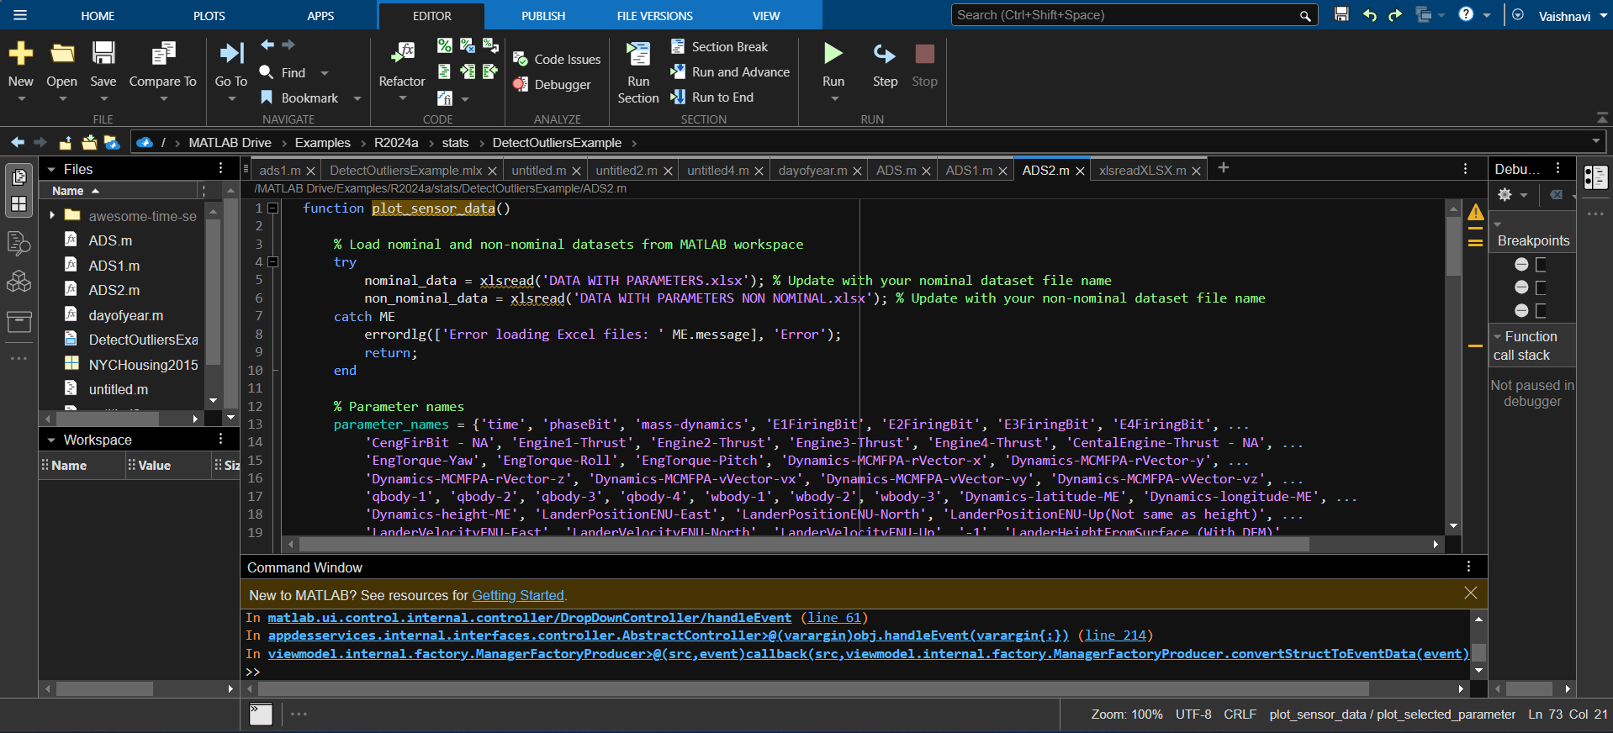

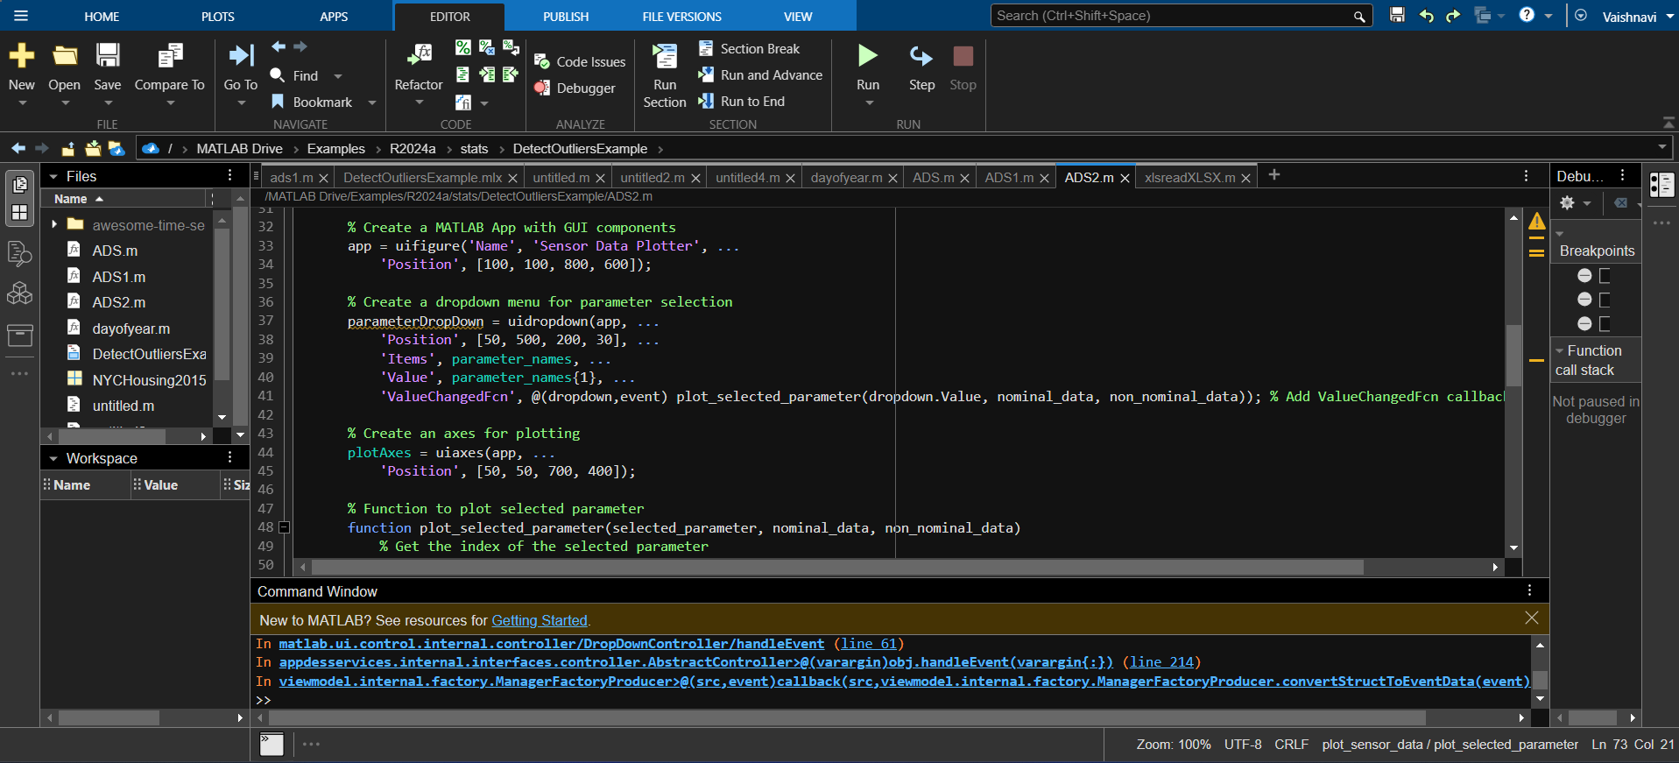

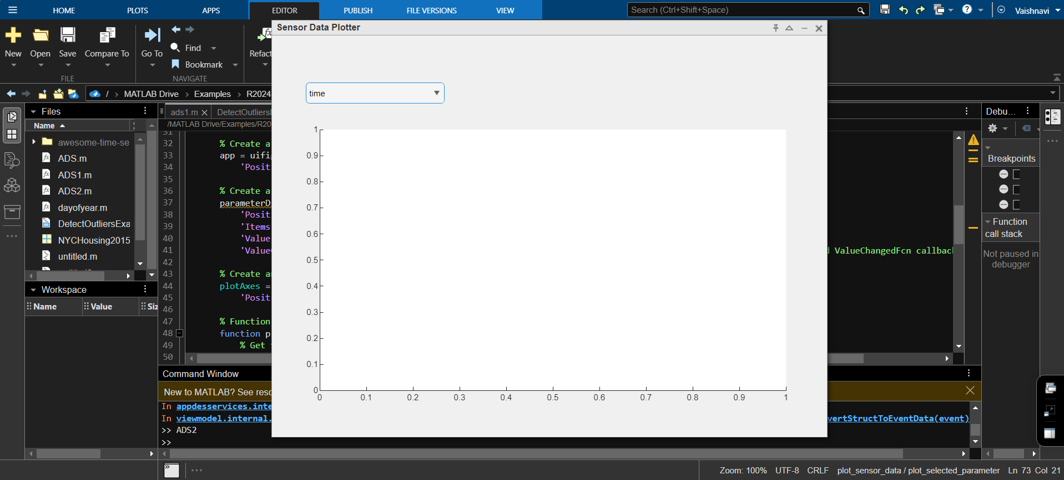

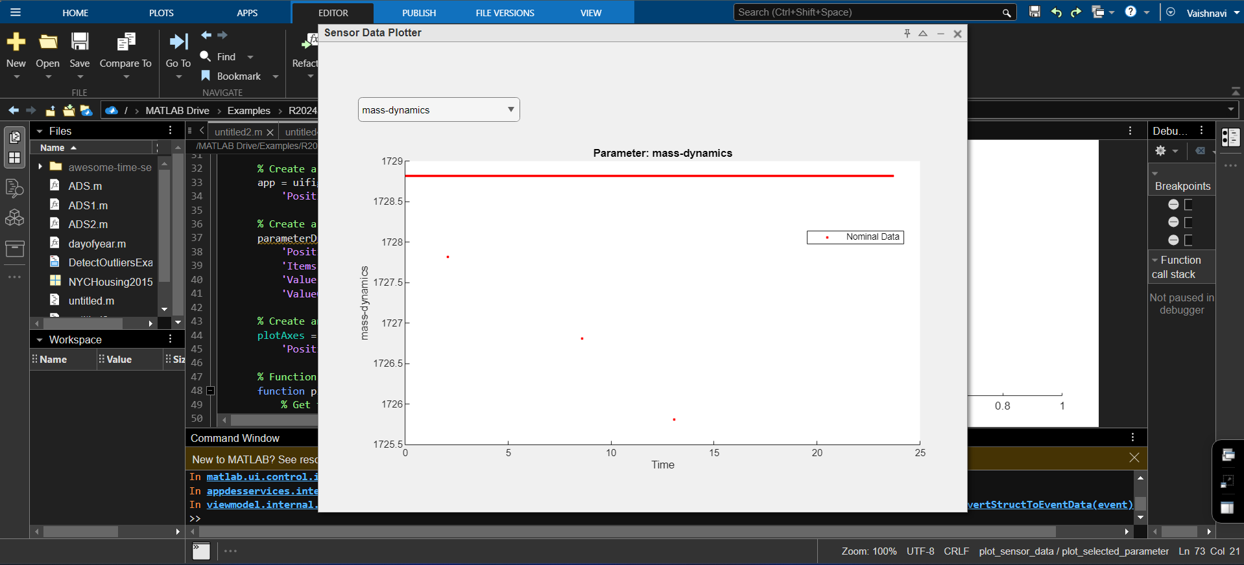

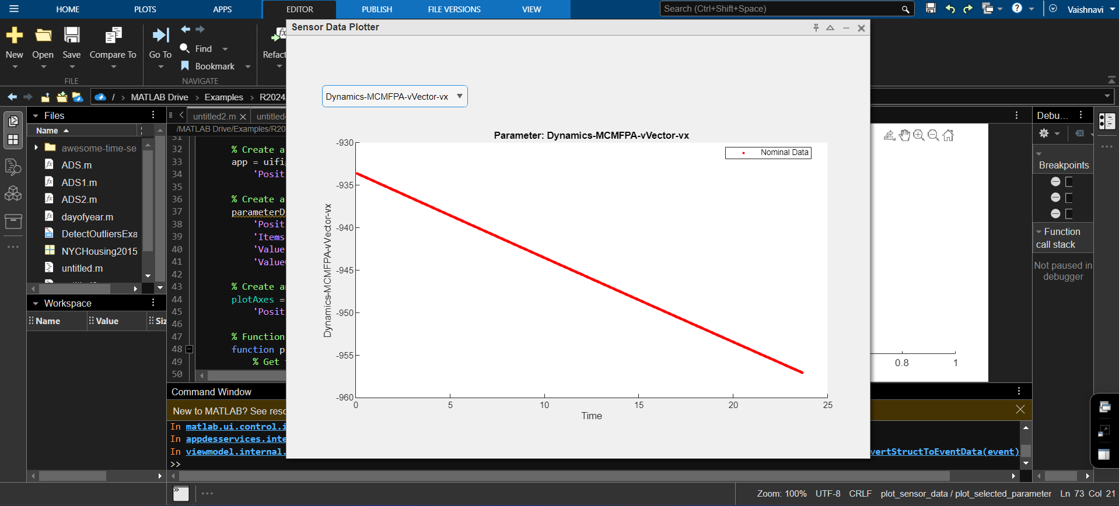

Fig : Representation using PySimpleGUI

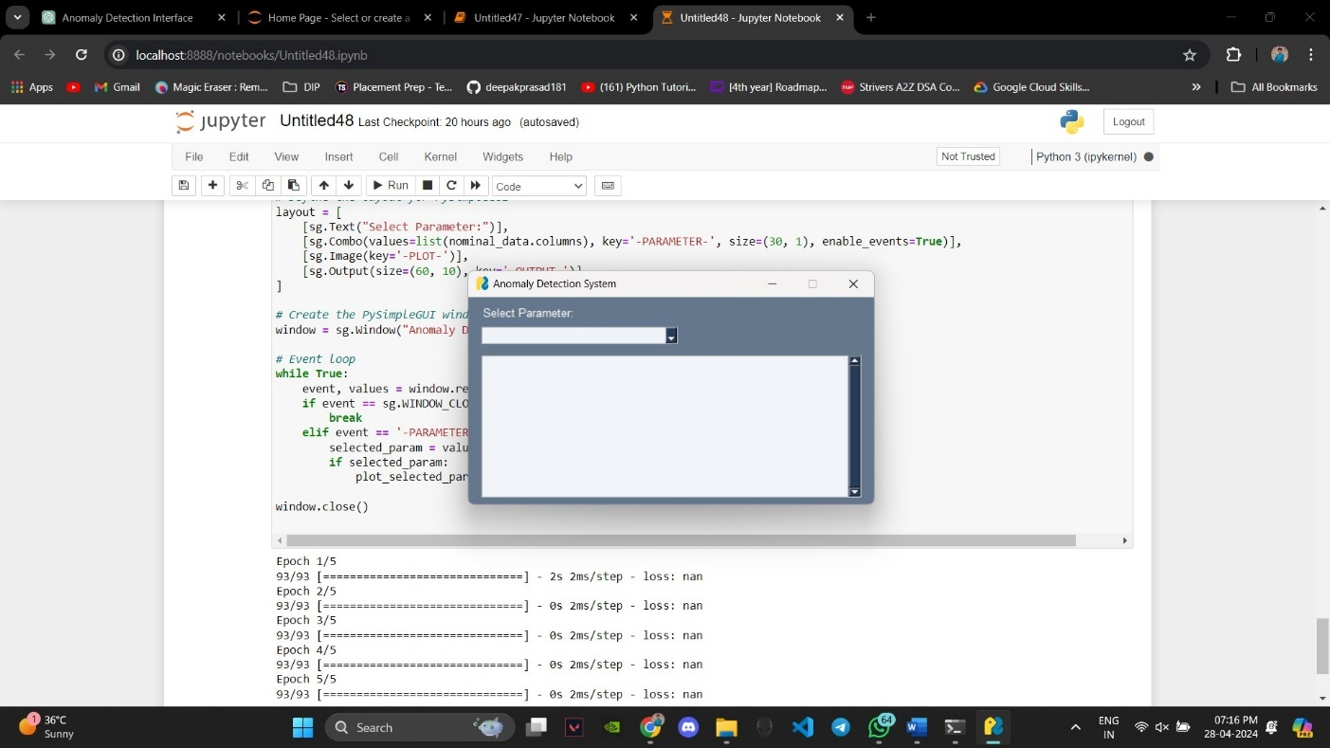

Fig : Parameter selection

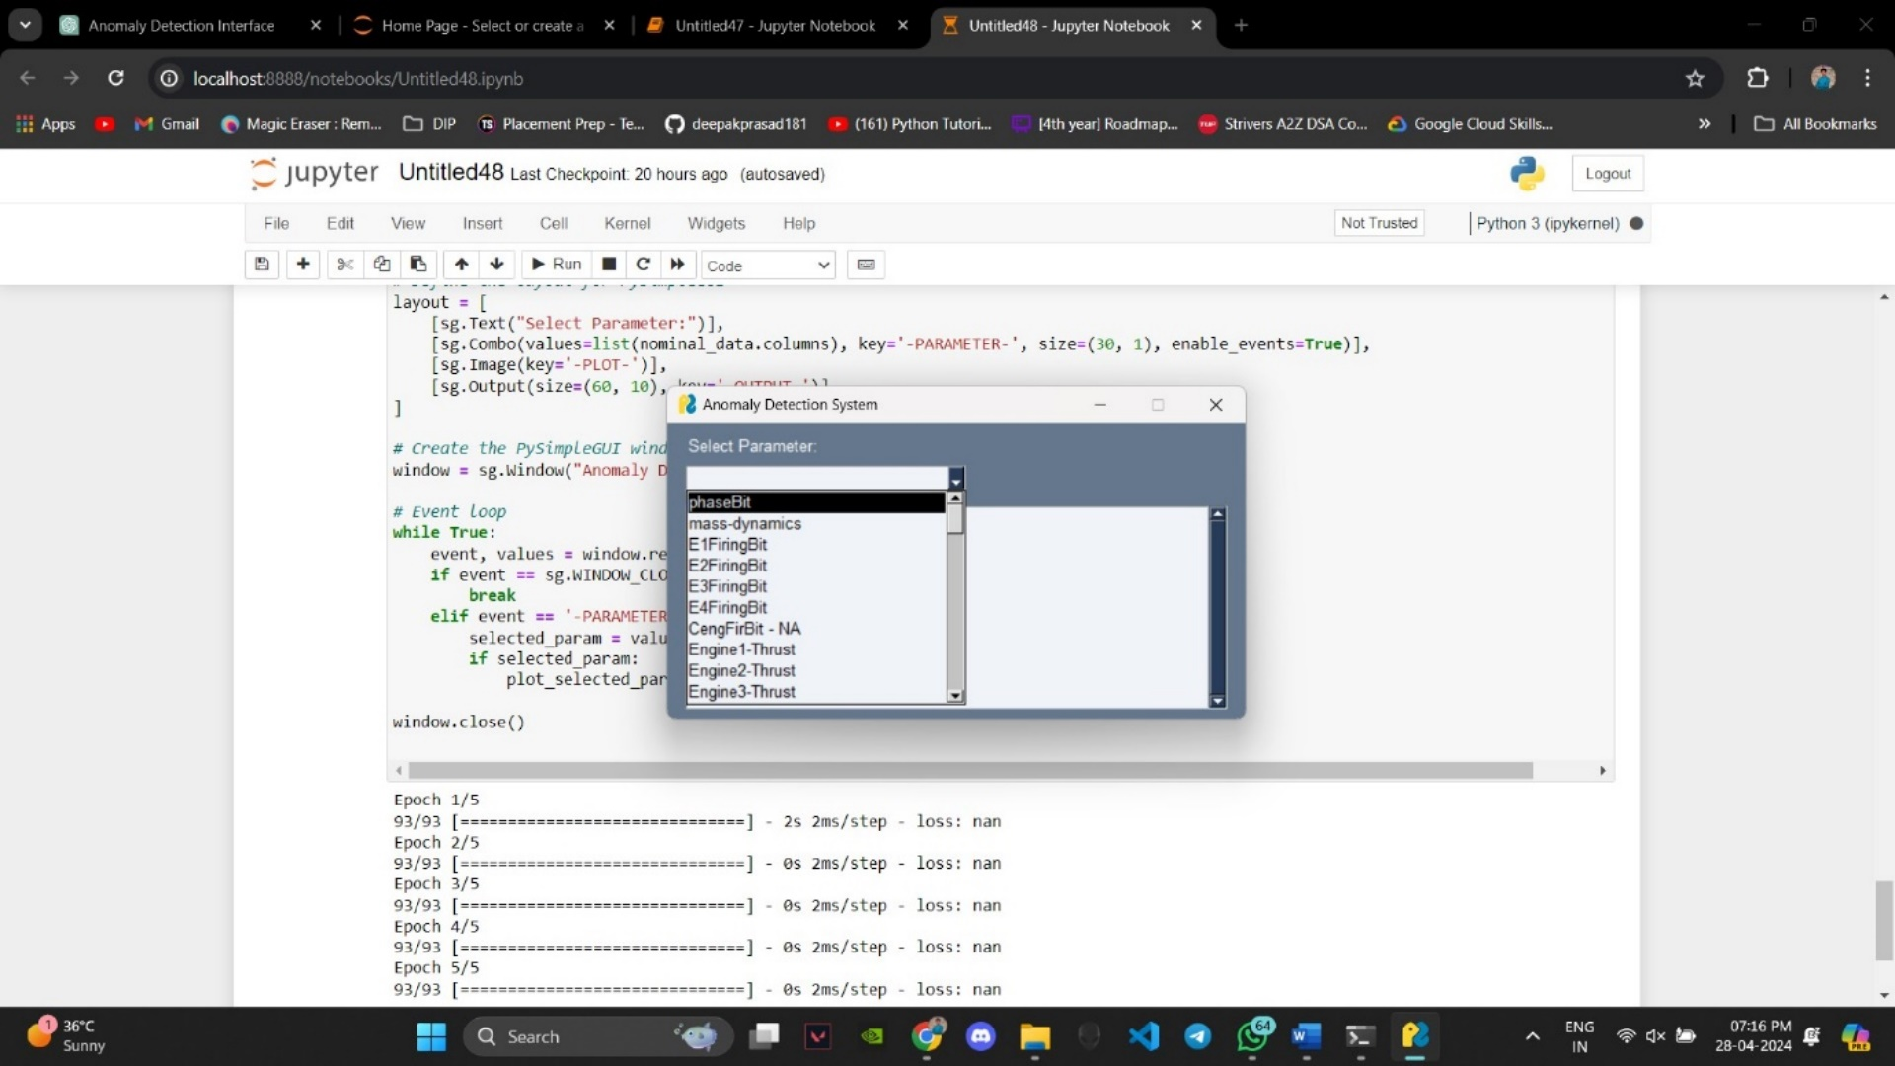

Fig : Plotting module

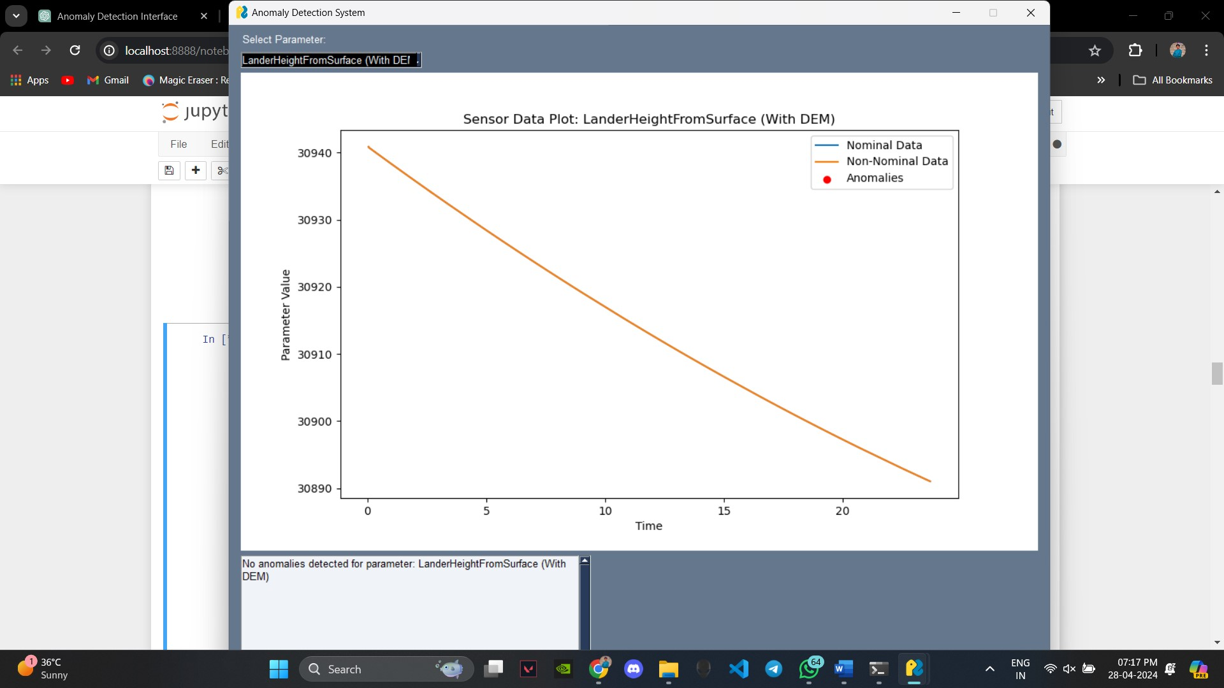

Fig : Anomaly detection module

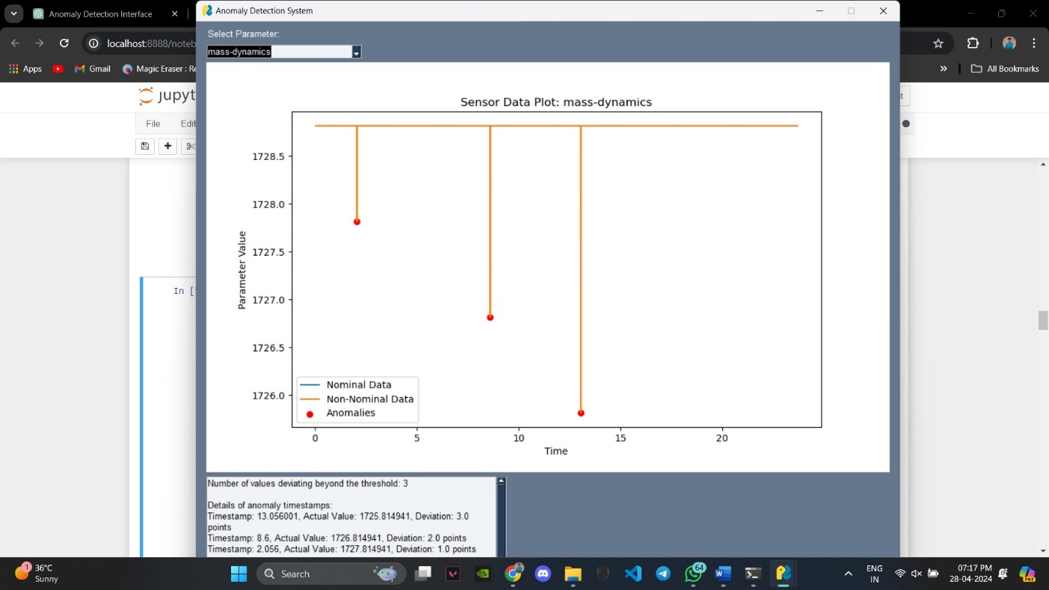

Fig: Anomaly detected metadata



Fig: Non-Nominal data plot for Mass-Dynamics

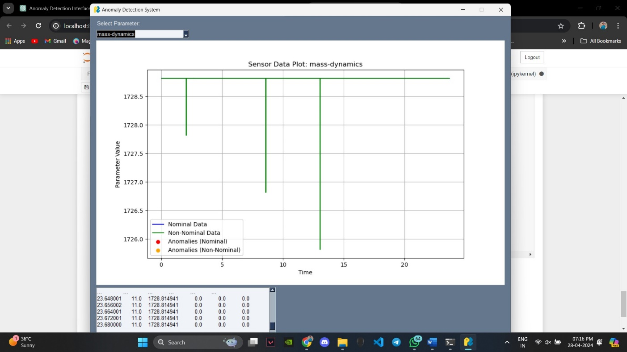

Fig: Parameter Comparison

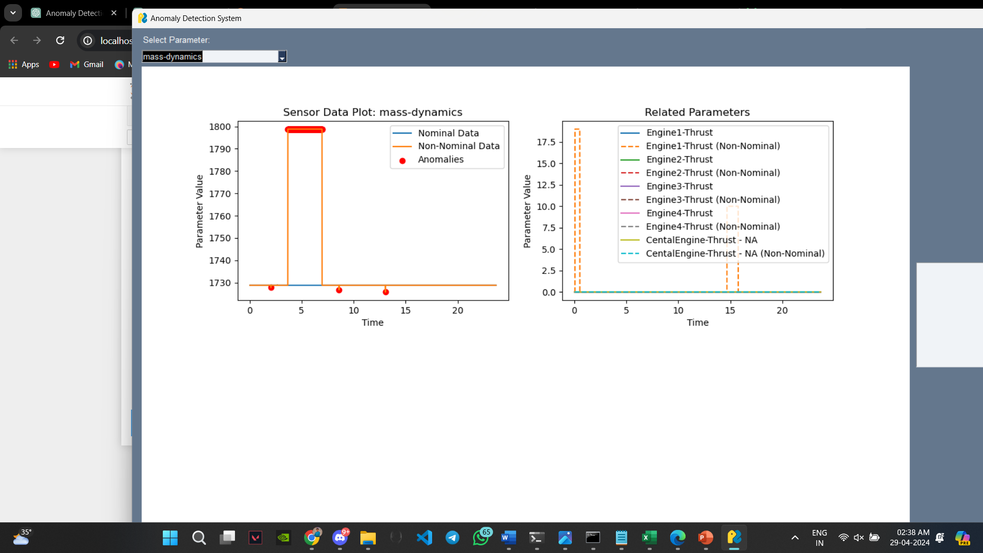

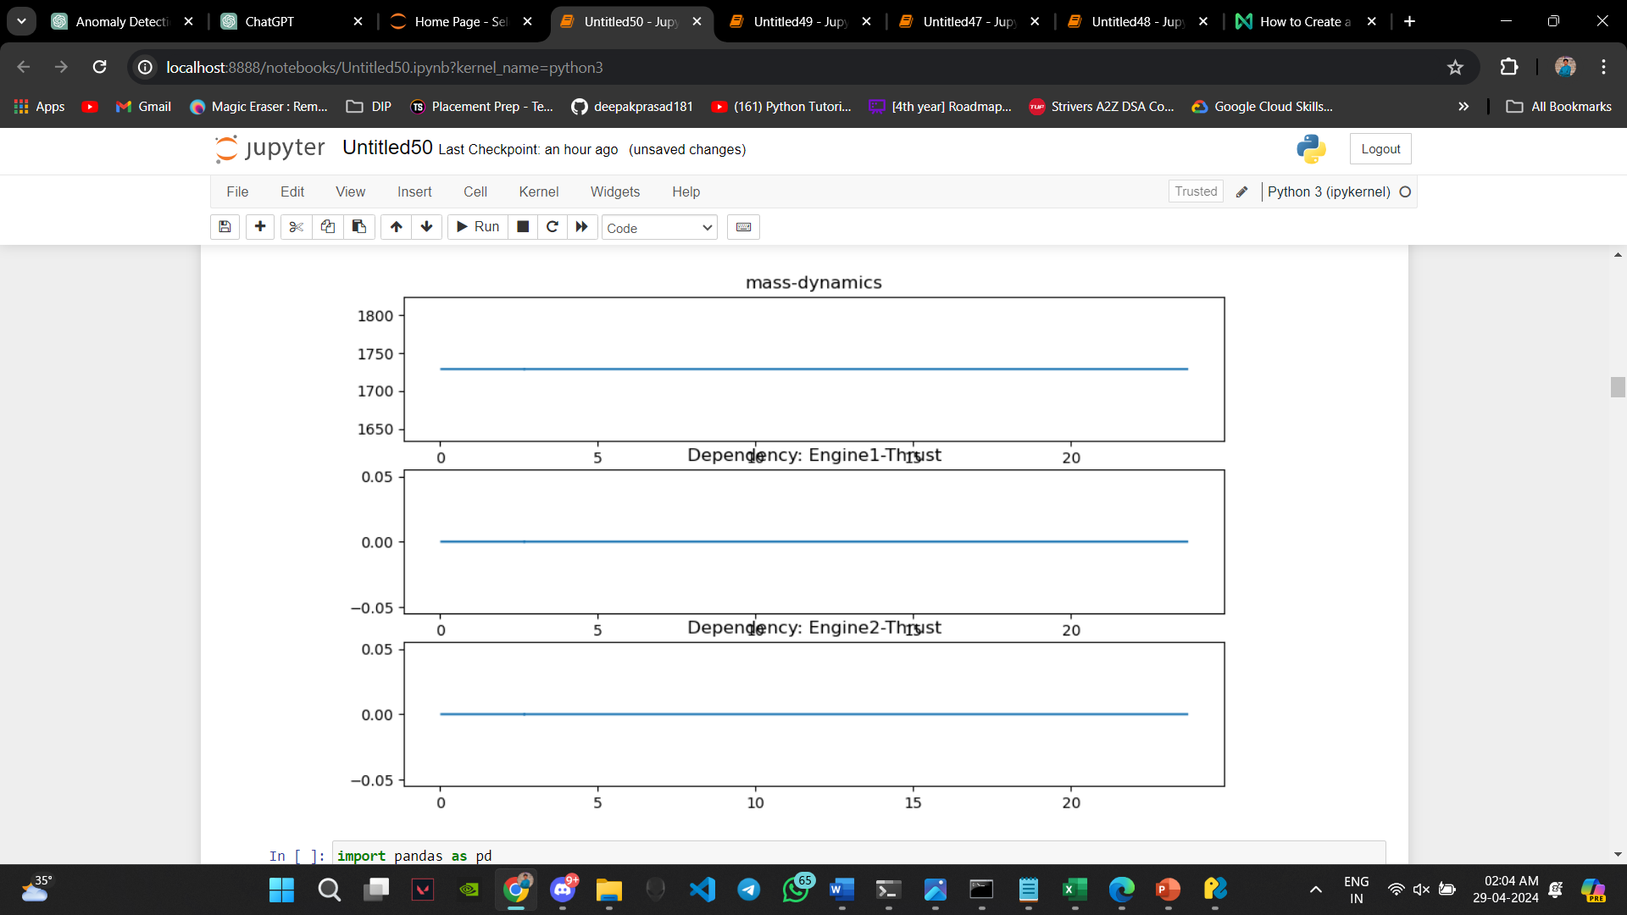

**8. REFERENCES**

1. Chandola, V., Banerjee, A., & Kumar, V. (2009). Anomaly detection: A survey. ACM computing surveys (CSUR), 41(3), 1-58.

2. Hawkins, D. M. (1980). Identification of outliers. Chapman and Hall.

3. Barnett, V., & Lewis, T. (1994). Outliers in statistical data. John Wiley & Sons.

4. Breunig, M. M., Kriegel, H. P., Ng, R. T., & Sander, J. (2000). LOF: Identifying density-based local outliers. In ACM sigmod record (Vol. 29, No. 2, pp. 93-104).

5. Ramaswamy, S., Rastogi, R., & Shim, K. (2000). Efficient algorithms for mining outliers from large data sets. In ACM SIGMOD Record (Vol. 29, No. 2, pp. 427-438).

6. Aggarwal, C. C., & Yu, P. S. (2001). Outlier detection for high dimensional data. In Proceedings of the 2001 ACM SIGMOD international conference on Management of data (pp. 37-46).

7. Knorr, E. M., & Ng, R. T. (1998). Algorithms for mining distance-based outliers in large datasets. In Proceedings of the 24th International Conference on Very Large Data Bases (VLDB'98) (pp. 392-403).

8. Agrawal, R., & Srikant, R. (1994). Fast algorithms for mining association rules. In Proc. 20th Int. Conf. Very Large Data Bases (pp. 487-499).

9. Schölkopf, B., & Smola, A. J. (2002). Learning with kernels: support vector machines, regularization, optimization, and beyond. MIT press.

10. Ramaswamy, S., Rastogi, R., & Shim, K. (2000). Efficient algorithms for mining outliers from large data sets. In ACM SIGMOD Record (Vol. 29, No. 2, pp. 427-438).

11. Aggarwal, C. C., & Yu, P. S. (2001). Outlier detection for high dimensional data. In Proceedings of the 2001 ACM SIGMOD international conference on Management of data (pp. 37-46).

12. Chandola, V., & Vatsavai, R. R. (2009). A scalable kernel method for anomaly detection in high-dimensional data sets. ACM Transactions on Intelligent Systems and Technology (TIST), 1(1), 1-39.

13. Pang, G., & Yu, P. S. (2005). Anomaly detection with multiple hypothesis testing. In Proceedings of the eleventh ACM SIGKDD international conference on Knowledge discovery in data mining (pp. 775-780).

14. Goldstein, M., & Uchida, S. (2016). A comparative evaluation of unsupervised anomaly detection algorithms for multivariate data. PloS one, 11(4), e0152173.